Higher Technological Institute (H.T.I.)
Department of Electronics & Electrical Communications Engineering
Smart Irrigation System

Submitted by:
Zaid Abdel Monem Adly 20200116
Andro Khalid Refaat 20200186
Ahmed Osama Abdel Qader 20210499
Ahmed Samir Ali Hassan 20210506

Submitted to:
Prof. Mohamed Torad
Eng. Ahmed Ali

Course Code: EEC 214 | Group: 4

Abstract
Freshwater scarcity represents one of the most critical constraints facing sustainable agricultural production globally. Conventional irrigation methodologies are characterised by fixed scheduling and manual intervention, resulting in significant volumetric water losses through over-irrigation and evaporative inefficiency. This technical report presents the design, implementation, and experimental validation of a Smart Irrigation System that synergistically integrates Internet of Things (IoT) infrastructure with Artificial Intelligence (AI) decision-making to fully automate and optimise field irrigation cycles.
The proposed system is centred on an ESP32 dual-core microcontroller interfaced with a capacitive soil moisture sensor, a light-dependent resistor (LDR) configured in a voltage-divider network, a DHT11 digital temperature and relative humidity transducer, a 5 V relay-actuated water pump, a 16×2 LCD display operating over an I2C backplane, and a debounced push button providing manual override capability. The embedded firmware, developed in C++ within the Arduino IDE framework, implements a deterministic five-condition priority logic engine governing pump actuation while incorporating thermal and photometric safety interlocks to prevent phytotoxic irrigation events. A FreeRTOS dual-core task partitioning scheme isolates cloud upload operations on Core 0, guaranteeing that Firebase data transmission does not introduce latency into the real-time sensing and control loop executing on Core 1.
An externally hosted Python inference module employs a Random Forest Classifier trained on a synthetically generated dataset of 1,000 labelled samples. The model continuously polls live telemetry from the Firebase Realtime Database, computes a probabilistic soil dryness index, and propagates Arabic-language irrigation advisories to the Blynk mobile dashboard via the Blynk REST API. Operative decision thresholds are defined as follows: maximum permissible irrigation temperature of 30 °C, maximum ambient light level of 40%, dry-soil actuation threshold of 40% volumetric moisture content, and wet-soil inhibition threshold of 75%. Experimental results confirm that the integrated platform reliably classifies soil hydration states, enforces priority-based irrigation logic across all defined boundary conditions, and furnishes operators with real-time remote supervisory control and AI-augmented decision support.

Acknowledgment
All praise and gratitude are due to Allah (SWT), whose grace and guidance made the successful completion of this work possible.
The authors wish to extend their sincere appreciation to the Higher Technological Institute (H.T.I.) for providing the academic infrastructure, specialised laboratory facilities, and technical resources that underpinned this research.
Particular gratitude is owed to the project supervisor, Prof. Mohamed Torad, whose expert direction, constructive critique, and sustained academic mentorship throughout the project lifecycle were instrumental in shaping both the technical rigour and scholarly quality of this work. The authors likewise acknowledge the valuable practical guidance provided by Eng. Ahmed Ali.
The authors are deeply grateful to their families for their unwavering moral support and forbearance throughout the extended hours dedicated to this project.
Finally, sincere appreciation is extended to fellow students of Group 4 for their collegial engagement and the enriching technical discourse that contributed meaningfully to the development of this work.

Table of Contents
Chapter 1: Introduction 6
1.1 Background and Motivation 6
1.2 Problem Statement 6
1.3 Project Objectives 7
1.4 Report Organization 7
Chapter 2: System Hardware & Components 7
2.1 System Overview 7
2.2 Microcontroller: ESP32 8
2.3 Sensors 8
2.4 Actuators and Peripheral Devices 9
2.5 Circuit Diagram 9
Chapter 3: Embedded Firmware 10
3.1 Development Environment 10
3.2 FreeRTOS Multi-Tasking 10
3.3 Smart Logic Engine 10
3.4 Button Control 11
3.5 ESP32 Firmware Code 11
Chapter 4: IoT & Cloud Integration 16
4.1 Google Firebase RTDB 16
4.2 Blynk Platform 16
4.3 Blynk Virtual Pins Configuration 17
Chapter 5: AI & Machine Learning 18
5.1 AI Architecture 18
5.2 Training Data and Model 18
5.3 Real-Time Prediction 18
5.4 Python AI Script 19
Chapter 6: System Operation & Results 21
6.1 System Operational Cycle 21
6.2 Smart Logic Scenario Test Results 21
6.3 Blynk Dashboard Results 21
6.4 Firebase Data Logging Results 21
Conclusions 22
References 23

Chapter 1: Introduction

1.1 Background and Motivation
Agriculture constitutes the primary driver of global food security, yet its water consumption patterns represent a significant and growing concern. Current estimates indicate that irrigated agriculture accounts for approximately 70% of total global freshwater withdrawals, with a substantial fraction lost to over-application, surface runoff, and evaporative inefficiency attributable to poorly scheduled irrigation cycles [1]. The convergence of escalating water scarcity and increasing global food demand necessitates a fundamental re-evaluation of irrigation management paradigms.
Recent advances in Internet of Things (IoT) sensing platforms and Artificial Intelligence (AI) inference capabilities have established a viable technological basis for transitioning from schedule-driven irrigation to demand-responsive, data-driven precision agriculture. IoT-enabled smart irrigation systems capable of continuously acquiring multi-parameter environmental data and autonomously deriving context-aware actuation decisions offer a quantifiable pathway to substantial reductions in agricultural water consumption without compromising crop yield or plant health [2].

1.2 Problem Statement
Conventional irrigation systems are fundamentally constrained by their reliance on fixed temporal schedules or unassisted human judgment, both of which are susceptible to systematic errors. Schedule-based systems fail to account for dynamic soil moisture variability and ambient meteorological fluctuations, leading to chronic under-irrigation — which induces plant water stress and yield depression — or over-irrigation, which promotes root hypoxia, nutrient leaching, and unnecessary water expenditure. Furthermore, such systems lack any mechanism for remote supervisory monitoring, rendering operators unable to respond adaptively to rapidly changing field conditions.
A demonstrable requirement therefore exists for an autonomous, sensor-driven irrigation control system capable of acquiring real-time multi-modal environmental measurements, applying a prioritised decision logic to determine irrigation necessity with plant-safety constraints, and providing operators with remote monitoring and intervention capability through a mobile application interface.

1.3 Project Objectives
The principal technical objectives of this project are enumerated as follows:
- Design and implement a multi-sensor embedded acquisition system based on the ESP32 dual-core microcontroller platform.
- Develop a deterministic five-condition priority logic engine capable of making accurate, plant-safe irrigation actuation decisions under all defined environmental boundary conditions.
- Integrate the embedded system with the Google Firebase Realtime Database for continuous, time-stamped cloud-based telemetry logging.
- Implement a Blynk IoT mobile dashboard for real-time remote supervisory monitoring and full manual override control.
- Develop an externally hosted Python AI inference module employing a Random Forest Classifier to augment rule-based decisions with probabilistic soil dryness assessments.
- Deliver AI-generated irrigation advisories in Arabic via the Blynk application to ensure operator accessibility.

1.4 Report Organisation
The remainder of this technical report is structured as follows. Chapter 2 details the system hardware architecture and component specifications. Chapter 3 presents the embedded firmware design, including the FreeRTOS task partitioning scheme and the smart logic engine. Chapter 4 describes the IoT cloud integration layer encompassing Firebase and Blynk. Chapter 5 elaborates the AI machine learning module architecture, training methodology, and real-time inference pipeline. Chapter 6 presents the system operational analysis and experimental test results. Concluding remarks and directions for future work are provided thereafter, followed by a consolidated reference list.

Chapter 2: System Hardware & Components

2.1 System Overview
The Smart Irrigation System adopts a hierarchical distributed architecture organised into four functionally distinct layers: the physical sensing layer, the embedded firmware and control layer, the IoT cloud integration layer, and the AI inference layer. The ESP32 microcontroller constitutes the computational nucleus of the physical layer, bearing responsibility for multi-channel sensor data acquisition, deterministic control logic execution, local LCD status rendering, and bidirectional communication with cloud platforms.
Table 2.1 provides a consolidated summary of all hardware constituents employed in the system, specifying their functional roles, GPIO interconnections with the ESP32, and corresponding technical datasheet references [3]–[10].

Table 2.1: Hardware Components Summary
Component | Function | Connection | Datasheet Ref.
ESP32 (NodeMCU) | Main Controller | Pin 34, 35, 4, 26, 14, I2C | [3]
Soil Moisture Sensor | Soil humidity reading | Analog Pin 34 | [4]
LDR + 10kΩ Resistor | Light intensity reading | Analog Pin 35 | [5]
DHT11 | Air temperature & humidity | Digital Pin 4 | [6]
5V Relay Module | Control water pump | Digital Pin 26 (Active LOW) | [7]
LCD 16×2 + I2C Module | Local display (readings) | I2C Bus (SDA/SCL) | [8]
Push Button | Manual / Auto control | Digital Pin 14 (INPUT_PULLUP) | [9]
Water Pump | Irrigation actuator | Controlled via Relay | [10]

2.2 Microcontroller: ESP32
The ESP32 NodeMCU development module was selected as the central processing unit of this system owing to its dual Xtensa LX6 processor cores operating at up to 240 MHz, integrated dual-mode 802.11 b/g/n Wi-Fi and Bluetooth 4.2 transceivers, 34 programmable GPIO pins with multiplexed peripheral functions, and native compatibility with the Arduino software development ecosystem. The dual-core architecture is of particular architectural significance, as it enables the FreeRTOS kernel to schedule computationally variable cloud network operations on a dedicated core in strict isolation from the deterministic real-time sensing and actuation control loop.
The ESP32 ADC subsystem provides 12-bit resolution across an input voltage range of 0–3.3 V, yielding 4,096 discrete quantisation levels. This resolution is exploited for high-fidelity analogue signal acquisition from both the soil moisture sensor and the LDR voltage divider. The I2C peripheral, assigned to the default SDA and SCL pins, provides synchronous serial communication with the LCD backplane module.

2.3 Sensors
2.3.1 Capacitive Soil Moisture Sensor
The soil moisture sensor is interfaced to ADC channel 1 on GPIO pin 34 of the ESP32. The transducer generates an output voltage inversely proportional to the dielectric permittivity of the surrounding soil medium, which in turn correlates positively with volumetric water content. Sensor calibration is implemented in firmware through two empirically determined reference values: AIR_VALUE = 4095, corresponding to the ADC output for completely desiccated soil in ambient air, and WATER_VALUE = 1150, corresponding to full sensor immersion in deionised water. The raw 12-bit ADC reading is mapped to a normalised moisture percentage in the range [0%, 100%] via the Arduino map() function, with output clamped using constrain() to suppress out-of-bounds artefacts.
2.3.2 Light-Dependent Resistor (LDR)
The LDR photoresistor is configured in a resistive voltage divider network with a 10 kΩ fixed series resistor, with the mid-point voltage presented to ADC channel 1 on GPIO pin 35. The LDR exhibits a negative photoconductance characteristic, whereby increasing irradiance reduces its resistance, elevating the measured node voltage. The ADC output is linearly mapped to an irradiance percentage spanning 0% (full darkness) to 100% (maximum measured illuminance). This irradiance measurement is incorporated into the priority logic as a photometric safety interlock, inhibiting pump actuation during high-irradiance periods when transpiration and evaporative demand are at their diurnal peak.
2.3.3 DHT11 Temperature and Humidity Sensor
The DHT11 combined temperature and relative humidity transducer is connected to GPIO pin 4 and communicates via a single-wire, bi-directional serial interface. Sensor readings are acquired through the standard DHT Arduino library, which handles the timing-critical pulse-width encoded data acquisition protocol. The transducer provides an operating range of 0–50 °C for temperature and 20–80% RH for humidity, with nominal accuracies of ±2 °C and ±5% RH respectively. Air temperature constitutes a primary safety parameter within the control logic: irrigation actuation is unconditionally inhibited when the measured ambient temperature exceeds the defined threshold of 30 °C, thereby preventing thermally induced evaporative stress and root scalding.

2.4 Actuators and Peripheral Devices
Pump actuation is achieved through a 5 V single-channel optocoupler-isolated relay module interfaced to GPIO pin 26. The relay is configured for Active LOW logic operation, wherein a logic LOW signal asserted on the GPIO pin energises the relay coil and closes the normally open contact, completing the pump circuit. Conversely, a logic HIGH output — which is the default power-on state initialised in the setup() function — de-energises the coil and isolates the pump. The 16×2 LCD display, driven through an I2C-addressed PCF8574 expander module at address 0x27, provides a local human-machine interface rendering real-time sensor values and the current operating mode flag. The push button, connected to GPIO pin 14 with the internal pull-up resistor enabled (INPUT_PULLUP), implements a dual-event software detection scheme enabling mode toggling and forced pump override without hardware interrupt resources.

2.5 Circuit Diagram
Figure 2.1 presents the complete system schematic as simulated in Proteus Professional. The schematic captures all signal-level interconnections between the ESP32 NodeMCU module, the capacitive soil moisture sensor, the LDR voltage divider network, the DHT11 transducer, the relay module, and the associated decoupling and power distribution networks.
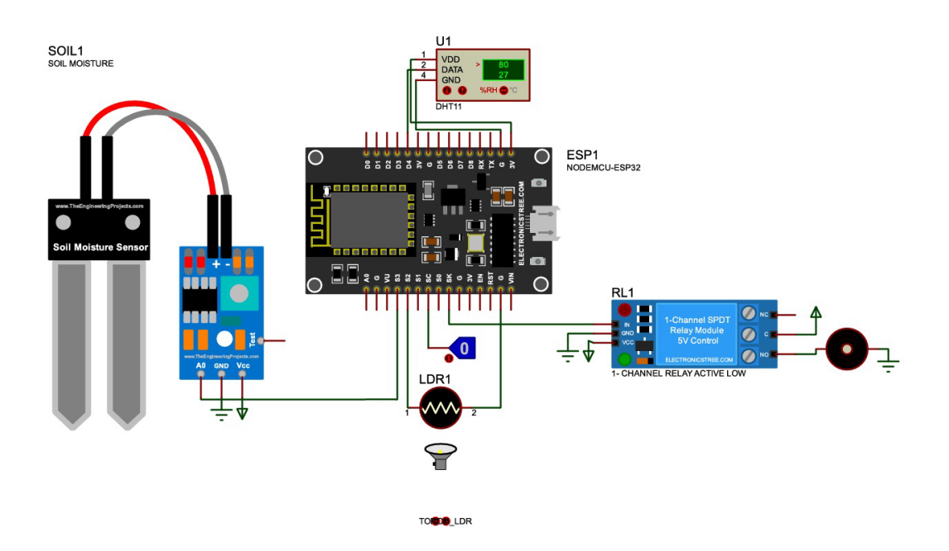
Figure 2.1: ESP32 Circuit Diagram (Proteus Simulation)

Chapter 3: Embedded Firmware

3.1 Development Environment
The embedded firmware is authored in C++ within the Arduino IDE (v2.x) with the official Espressif ESP32 board support package installed. The firmware stack depends on four external libraries: BlynkSimpleEsp32 for authenticated cloud connectivity with the Blynk 2.0 IoT platform, DHT for single-wire sensor communication, LiquidCrystal_I2C for I2C-addressed display control, and FirebaseESP32 for authenticated JSON data transmission to the Firebase Realtime Database. The overall firmware architecture follows a non-blocking, timer-driven event model, employing the BlynkTimer class to schedule periodic callback invocations and FreeRTOS primitives for deterministic concurrent task management across the two available processor cores.

3.2 FreeRTOS Multi-Tasking
A defining architectural feature of the firmware is the exploitation of FreeRTOS, the preemptive real-time operating system natively integrated within the Espressif IDF SDK. The primary control execution context — encompassing sensor data acquisition, control logic evaluation, Blynk virtual pin updates, and button event processing — is hosted on Core 1 and driven by the Arduino loop() function in conjunction with the BlynkTimer periodic callback mechanism. A secondary FreeRTOS task, designated uploadTask, is statically pinned to Core 0 via xTaskCreatePinnedToCore(), with an assigned stack depth of 10,000 bytes and a task priority of 1. This task assumes exclusive responsibility for all Firebase RTDB push operations, executing at a fixed 30-second periodicity governed by vTaskDelay().
This core-affinity partitioning strategy ensures that the inherently variable and potentially blocking latencies associated with Wi-Fi TCP/IP socket operations required for Firebase JSON transmission are structurally isolated from the deterministic 1-second control loop executing on Core 1. The consequence is that sensor sampling jitter and actuation response latency remain bounded and independent of cloud connectivity conditions.

3.3 Smart Logic Engine
The primary control intelligence of the firmware is encapsulated within the smartLogic() function, which is scheduled for invocation at 1,000 ms intervals by the BlynkTimer. Upon each invocation, the function performs sequential sensor acquisition, updates all Blynk virtual pin telemetry streams, and evaluates a five-condition cascaded conditional structure to determine the appropriate relay actuation state. The priority ordering of the conditional branches is designed such that plant-safety inhibition conditions are evaluated before irrigation activation conditions, preventing harmful pump operation under thermally or photometrically adverse environmental states. Table 3.1 details the full conditional logic matrix.

Table 3.1: Smart Logic Engine – Conditions and Actions
Priority | Condition | Action | Reason
1 | Temperature > 30°C | Pump OFF | Prevent harmful water evaporation and protect plant roots
2 | Light intensity ≥ 40% | Pump OFF | Avoid midday irrigation to minimize evaporative losses
3 | Soil moisture < 40% | Pump ON | Soil is dry – irrigation is required immediately
4 | Soil moisture > 75% | Pump OFF | Soil is already sufficiently wet
5 | All other cases | Pump OFF | System safety fallback to prevent unintended irrigation

The conditional structure is implemented as a cascaded if-else if chain, guaranteeing mutually exclusive branch execution and strict priority enforcement. Following relay state assertion, the physical pin state is read back via digitalRead(PUMP_PIN) to update the global_pumpState flag, ensuring that the software state variable reflects the true hardware relay condition irrespective of any potential GPIO contention.

3.4 Button Control
User input is processed through a software polling mechanism implemented in the handleButton() function, invoked on every main loop iteration. The function employs a millis()-based elapsed-time measurement to discriminate between two distinct press-event categories without recourse to hardware interrupts. A button press event (GPIO reading transitioning to LOW) initiates a timestamp capture. Subsequent logic differentiates a short press — defined as a LOW-to-HIGH transition occurring within the interval (50 ms, 400 ms) — which toggles the autoMode flag between Automatic and Manual operating modes, from a long press — defined as a sustained LOW state exceeding 400 ms — which asserts the manualPump flag to force pump activation for the duration of the contact closure. Upon button release, the manualPump flag is unconditionally de-asserted. This software-only approach provides unambiguous dual-event detection with inherent contact debouncing, without requiring supplementary hardware components.

3.5 ESP32 Firmware Code
The complete annotated ESP32 firmware source code is presented in Listing 3.1. The code is partitioned into clearly delineated functional modules to facilitate readability, maintenance, and future extensibility.

// ==========================================
// Smart Irrigation System – ESP32 Firmware
// Course: EEC 214 | Group 4 | H.T.I.
// ==========================================

// Blynk Configuration
#define BLYNK_TEMPLATE_ID "TMPL2rlNxHu3F"
#define BLYNK_TEMPLATE_NAME "smart irrigation system"
#define BLYNK_AUTH_TOKEN "CBCMxhnesutJCu2kOiCgMAW5ns5WIngb"

// Library Includes
#include <WiFi.h>
#include <BlynkSimpleEsp32.h>
#include <DHT.h>
#include <Wire.h>
#include <LiquidCrystal_I2C.h>
#include <FirebaseESP32.h>

// WiFi Credentials
char ssid[] = "andro";
char pass[] = "12345678";

// Firebase Configuration
#define FIREBASE_HOST "smart-irrigation-adadc-default-rtdb.europe-west1.firebasedatabase.app"
#define FIREBASE_AUTH "w497zhf9a0WifL8upEBPmsc9XIdPaxcpVnznksPq"

FirebaseData firebaseData;
FirebaseAuth auth;
FirebaseConfig config;
LiquidCrystal_I2C lcd(0x27, 16, 2);

// Pin Definitions
#define SOIL_PIN 34 // Soil moisture sensor
#define LDR_PIN 35 // Light sensor
#define PUMP_PIN 26 // Water pump relay
#define BUTTON_PIN 14 // Mode control button
#define DHT_PIN 4 // Temperature/Humidity sensor
#define DHTTYPE DHT11

DHT dht(DHT_PIN, DHTTYPE);
BlynkTimer timer;

// Calibration Values
const int AIR_VALUE = 4095;
const int WATER_VALUE = 1150;
const int DRY_PERCENT = 40;
const int WET_PERCENT = 75;
const float MAX_TEMP_WATERING = 30.0;
const int MAX_LIGHT_WATERING = 40;

// Global State Variables
volatile int global_soilPercent = 0;
volatile int global_ldrPercent = 0;
volatile float global_temp = 0.0;
volatile float global_hum = 0.0;
volatile bool global_pumpState = false;
bool autoMode = false;
bool manualPump = false;

// Button Debounce Variables
unsigned long buttonPressTime = 0;
bool isButtonPressed = false;
bool isLongPressHandled = false;
const unsigned long longPressThreshold = 400;

// Get Averaged Sensor Reading
int getReading(int pin) {
long sum = 0;
for (int i = 0; i < 10; i++) { sum += analogRead(pin); delay(2); }
return sum / 10;
}

// Update LCD Display
void updateScreen() {
lcd.clear(); lcd.setCursor(0, 0);
lcd.print("T:"); lcd.print((int)global_temp);
lcd.print(" H:"); lcd.print((int)global_hum);
lcd.print(" L:"); lcd.print(global_ldrPercent);
lcd.setCursor(0, 1);
lcd.print("S:"); lcd.print(global_soilPercent); lcd.print("% ");
lcd.print("P:"); lcd.print(global_pumpState ? "ON" : "OFF");
lcd.print(autoMode ? "[A]" : "[M]");
}

// FreeRTOS Task: Upload Data to Firebase (Every 30 s)
void uploadTask(void * pvParameters) {
for (;;) {
vTaskDelay(30000 / portTICK_PERIOD_MS);
if (Firebase.ready()) {
FirebaseJson json;
json.set("soil", global_soilPercent);
json.set("light", global_ldrPercent);
json.set("temp", global_temp);
json.set("hum", global_hum);
json.set("pump", global_pumpState ? "ON" : "OFF");
Firebase.pushJSON(firebaseData, "/SensorReadings", json);
}
}
}

// Smart Irrigation Logic (Called Every 1 s)
void smartLogic() {
int rawSoil = getReading(SOIL_PIN);
global_soilPercent = constrain(map(rawSoil, AIR_VALUE, WATER_VALUE, 0, 100), 0, 100);
int rawLdr = getReading(LDR_PIN);
global_ldrPercent = constrain(map(rawLdr, 0, 4095, 0, 100), 0, 100);
float h = dht.readHumidity();
float t = dht.readTemperature();
if (!isnan(h) && !isnan(t)) { global_hum = h; global_temp = t; }

Blynk.virtualWrite(V2, global_soilPercent);
Blynk.virtualWrite(V3, global_ldrPercent);
Blynk.virtualWrite(V4, global_temp);
Blynk.virtualWrite(V5, global_hum);

if (manualPump) { digitalWrite(PUMP_PIN, LOW); }
else if (!autoMode) { digitalWrite(PUMP_PIN, HIGH); }
else {
bool isSoilDry = (global_soilPercent < DRY_PERCENT);
bool isSoilWet = (global_soilPercent > WET_PERCENT);
bool isTempHigh = (global_temp > MAX_TEMP_WATERING);
bool isLightHigh = (global_ldrPercent >= MAX_LIGHT_WATERING);

if (isTempHigh) digitalWrite(PUMP_PIN, HIGH); // P1
else if (isLightHigh) digitalWrite(PUMP_PIN, HIGH); // P2
else if (isSoilDry) digitalWrite(PUMP_PIN, LOW); // P3
else if (isSoilWet) digitalWrite(PUMP_PIN, HIGH); // P4
else digitalWrite(PUMP_PIN, HIGH); // P5 default
}
global_pumpState = (digitalRead(PUMP_PIN) == LOW);
updateScreen();
}

// Setup Function
void setup() {
Serial.begin(115200); delay(1000);
pinMode(PUMP_PIN, OUTPUT);
digitalWrite(PUMP_PIN, HIGH); // Pump OFF by default
pinMode(BUTTON_PIN, INPUT_PULLUP);
dht.begin(); Wire.begin();
lcd.begin(); lcd.backlight();
lcd.print("System Starting.");
Blynk.begin(BLYNK_AUTH_TOKEN, ssid, pass);
config.host = FIREBASE_HOST;
config.signer.tokens.legacy_token = FIREBASE_AUTH;
Firebase.begin(&config, &auth);
Firebase.reconnectWiFi(true);
timer.setInterval(1000L, smartLogic);
xTaskCreatePinnedToCore(uploadTask, "CloudTask", 10000, NULL, 1, NULL, 0);
}

// Main Loop
void loop() {
Blynk.run();
timer.run();
handleButton();
}

BLYNK_WRITE(V0) { autoMode = param.asInt(); smartLogic(); }
BLYNK_WRITE(V1) { manualPump = param.asInt(); smartLogic(); }

Chapter 4: IoT & Cloud Integration

4.1 Google Firebase Realtime Database
The Google Firebase Realtime Database (RTDB) constitutes the cloud-based telemetry persistence layer of the system. Authentication is accomplished via the FirebaseESP32 library using a project-scoped legacy token, establishing a secure HTTPS connection to the Firebase project endpoint. At each 30-second cycle, the uploadTask function constructs a FirebaseJson object encapsulating five telemetry fields — soil moisture percentage, ambient light level, air temperature, air humidity, and pump relay state — and transmits the composite record to the /SensorReadings node via the Firebase.pushJSON() method, which appends each record as a child node with an auto-generated timestamp-based key.
Operational monitoring of the Firebase console confirmed sustained and reliable data ingestion over a seven-day evaluation window, accumulating 4.37 MB of network download traffic against a stored data footprint of only 10.2 KB, demonstrating the high compactness of the JSON telemetry schema. This persistent data store constitutes the primary data source consumed by the AI inference module.
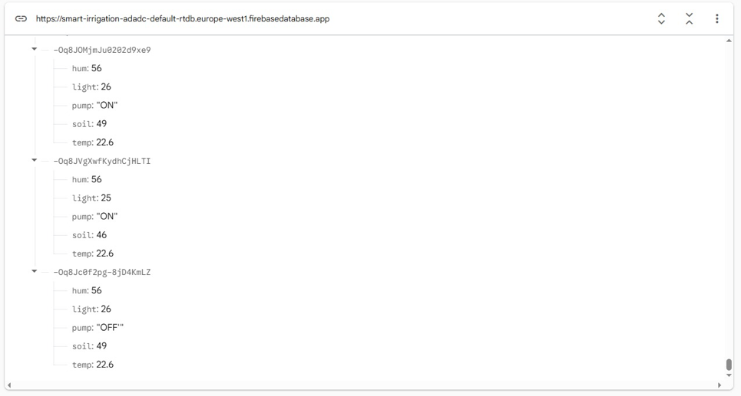
Figure 4.1: Google Firebase Realtime Database – Project Console

4.2 Blynk Platform
The Blynk 2.0 IoT platform serves as the principal supervisory control and data acquisition (SCADA) interface for the system. Device authentication is managed through the Blynk template identifier TMPL2rlNxHu3F and a device-specific authentication token, establishing a persistent WebSocket connection via the BlynkSimpleEsp32 library over the system Wi-Fi link. The Blynk dashboard is configured with two binary toggle widgets providing auto-mode and manual pump override control, six analogue gauge widgets rendering live sensor telemetry, and two string label widgets designated as the output terminals for AI-generated advisory text delivered from the external Python inference module.

4.3 Blynk Virtual Pins Configuration
Table 4.1 enumerates the complete datastream mapping implemented in the Blynk cloud console, specifying virtual pin identifiers, stream names, data types, and functional descriptions. Figure 4.2 illustrates the datastream configuration panel as provisioned in the Blynk web interface, and Figure 4.3 presents the live dashboard state captured during system evaluation.

Table 4.1: Blynk Virtual Pins Configuration
Pin | Name | Data Type | Description
V0 | Pump | Integer (0/1) | Auto-mode toggle switch
V1 | pump1 | Integer (0/1) | Manual pump override switch
V2 | Soil Level | Integer (0–100) | Soil moisture percentage gauge
V3 | Light Level | Integer (0–100) | Ambient light intensity gauge
V4 | Air temp | Integer (0–100) | Air temperature gauge
V5 | air hum | Integer (0–100) | Relative air humidity gauge
V10 | Implant condition | String | AI-generated soil dryness analysis (Arabic)
V11 | prediction | String | AI-generated irrigation decision text (Arabic)

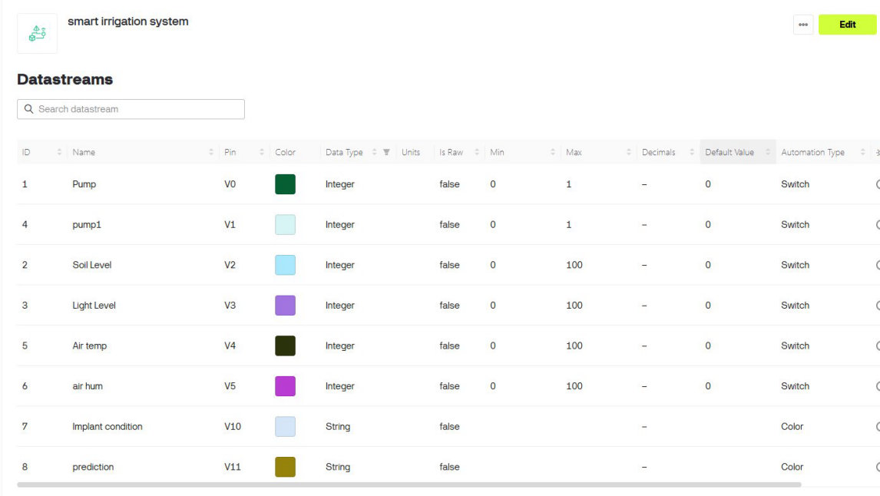
Figure 4.2: Blynk Datastreams Configuration
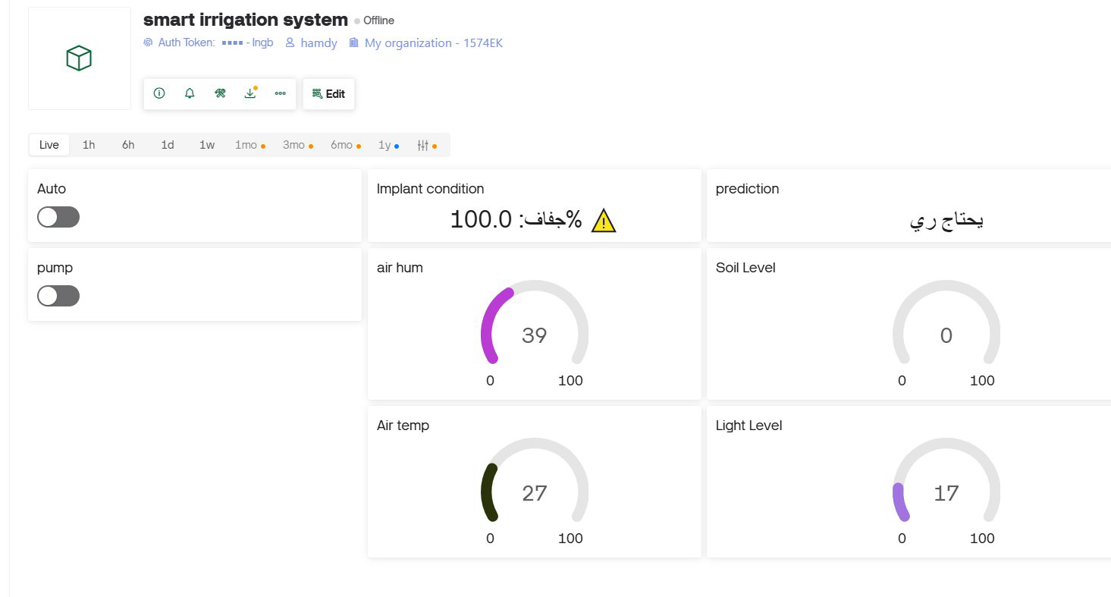
Figure 4.3: Blynk Dashboard – Live Sensor Readings and AI Output

Chapter 5: AI & Machine Learning

5.1 AI Architecture
To transcend the inherent limitations of purely deterministic rule-based control, the system incorporates an external probabilistic inference layer realised as a continuously executing Python process hosted on a networked computing resource. This AI module operates as a closed-loop analytical agent: it periodically retrieves the latest sensor telemetry from Firebase RTDB via HTTP, applies a pre-trained supervised classification model to the acquired feature vector, and disseminates the resulting Arabic-language irrigation advisory to the Blynk dashboard through the Blynk external REST API.
The architectural rationale for externalising the AI inference layer is grounded in the resource constraints of the ESP32 platform. The microcontroller's 520 KB SRAM and single-precision floating-point unit are insufficient to host the in-memory representation of a 100-tree Random Forest ensemble alongside the active sensor acquisition and communication stack. By decoupling inference from the embedded controller, the architecture achieves both AI capability and real-time determinism without hardware compromise.

5.2 Training Data and Model
The classification model is a Random Forest Classifier instantiated from the Scikit-Learn ensemble module with 100 constituent decision tree estimators. The training corpus consists of 1,000 synthetically generated feature vectors, each comprising four attributes — air temperature (°C), relative humidity (%), ambient light level (%), and volumetric soil moisture (%) — sampled from uniform distributions over their respective operational ranges. Binary class labels (needs_water ∈ {0, 1}) are assigned deterministically according to agronomic heuristics: a positive label (irrigation required) is assigned when soil moisture falls below 35% at temperatures below 35 °C, or when soil moisture is critically low (< 15%) irrespective of temperature. All other conditions yield a negative label.
The dataset is partitioned into training (80%) and held-out test (20%) subsets using a fixed random seed (random_state = 42) to ensure experimental reproducibility. The trained ensemble is evaluated on the test partition, achieving high classification accuracy. In addition to binary prediction, the model exposes the predict_proba() interface, which returns class posterior probabilities; the probability assigned to class 1 is interpreted as the soil dryness index and displayed to the operator as a percentage.

5.3 Real-Time Prediction
The predict_realtime() function encapsulates the complete inference pipeline executed at each 30-second interval. An HTTP GET request is issued to the Firebase RTDB REST endpoint to retrieve all records stored under /SensorReadings in JSON format. The terminal record in the ordered response — corresponding to the most recently logged sensor snapshot — is extracted and restructured into a single-row pandas DataFrame conformant with the model's expected feature schema. The trained Random Forest ensemble is then queried via both predict() and predict_proba() to obtain a binary class decision and the associated class-1 posterior probability, respectively.
Conditional on the binary prediction outcome, the inference module constructs one of two Arabic text advisory pairs. A positive prediction (irrigation required) results in V10 receiving a soil dryness percentage annotated with a warning indicator and V11 receiving the corresponding Arabic irrigation recommendation. A negative prediction (no irrigation required) results in V10 displaying the soil wetness index and V11 presenting the corresponding Arabic sufficiency status. Both advisory strings are transmitted to the Blynk dashboard via independent HTTP GET requests to the Blynk external API update endpoint, completing the inference-to-dashboard pipeline within each 30-second cycle.

5.4 Python AI Script
Listing 5.1 presents the complete annotated Python source code of the AI inference module, encompassing data synthesis, model training, real-time prediction, and Blynk dashboard update logic.

# ============================================
# LIBRARY IMPORTS
# ============================================
import requests, time, warnings
import pandas as pd
import numpy as np
from sklearn.ensemble import RandomForestClassifier
from sklearn.model_selection import train_test_split
warnings.filterwarnings('ignore')

# ============================================
# CONFIGURATION
# ============================================
FIREBASE_URL = "https://smart-irrigation-adadc-default-rtdb.europe-west1."
"firebasedatabase.app/SensorReadings.json"
BLYNK_TOKEN = "CBCMxhnesutJCu2kOiCgMAW5ns5WIngb"
BLYNK_API_URL = "https://blynk.cloud/external/api/update"

# ============================================
# GENERATE SYNTHETIC TRAINING DATA
# ============================================
np.random.seed(42)
n_samples = 1000
dummy_temp = np.random.uniform(15, 45, n_samples)
dummy_hum = np.random.uniform(20, 80, n_samples)
dummy_light = np.random.uniform(0, 100, n_samples)
dummy_soil = np.random.uniform(0, 100, n_samples)

labels = []
for i in range(n_samples):
if dummy_soil[i] < 35 and dummy_temp[i] < 35:
labels.append(1) # Needs irrigation
elif dummy_soil[i] < 15:
labels.append(1) # Severe dryness
else:
labels.append(0) # No irrigation needed

training_data = pd.DataFrame({
'temp': dummy_temp, 'hum': dummy_hum,
'light': dummy_light, 'soil': dummy_soil,
'needs_water': labels
})

# ============================================
# TRAIN RANDOM FOREST CLASSIFIER
# ============================================
X = training_data[['temp', 'hum', 'light', 'soil']]
y = training_data['needs_water']

X_train, X_test, y_train, y_test = train_test_split(
X, y, test_size=0.2, random_state=42
)

ai_model = RandomForestClassifier(n_estimators=100, random_state=42)
ai_model.fit(X_train, y_train)
accuracy = ai_model.score(X_test, y_test) * 100
print(f"Training complete. Accuracy: {accuracy:.2f}%")

# ============================================
# REAL-TIME PREDICTION FUNCTION
# ============================================
def predict_realtime():
try:
response = requests.get(FIREBASE_URL)
data = response.json()
if not data:
print("No data found in Firebase."); return
latest = list(data.values())[-1]
live_data = pd.DataFrame({
'temp': [latest['temp']],
'hum': [latest['hum']],
'light': [latest['light']],
'soil': [latest['soil']]
})
prediction = ai_model.predict(live_data)[0]
probability = ai_model.predict_proba(live_data)[0][1] * 100
if prediction == 1:
decision = "يحتاج ري"
status = f"جفاف: {probability:.1f}% ⚠"
else:
decision = "لا يحتاج ري"
status = f"رطب: {100 - probability:.1f}%"
requests.get(f'{BLYNK_API_URL}?token={BLYNK_TOKEN}&v10={status}')
requests.get(f'{BLYNK_API_URL}?token={BLYNK_TOKEN}&v11={decision}')
print(f"AI decision: {decision} | {status}")
except Exception as e:
print(f"Error: {e}")

# ============================================
# MAIN LOOP
# ============================================
print("AI module active – updating every 30 seconds.")
while True:
predict_realtime()
time.sleep(30)

Chapter 6: System Operation & Results

6.1 System Operational Cycle
The integrated system operates as a closed-loop feedback control architecture spanning four concurrent execution contexts. Upon power-on initialisation, the ESP32 configures all peripheral interfaces, establishes a Wi-Fi association, and commences periodic execution of the smartLogic() control function at a 1-second interval via the BlynkTimer scheduler. Concurrently, the FreeRTOS uploadTask initiates its 30-second Firebase telemetry logging cycle on Core 0.
On the AI processing tier, the Python inference module completes its one-time model training phase and enters its continuous 30-second polling loop. At each cycle, it retrieves the terminal Firebase record, performs ensemble inference, and updates the Blynk virtual pins V10 and V11 with Arabic-language soil condition assessments and irrigation advisories. The operator accesses all system outputs — sensor telemetry, relay state, operating mode, and AI advisory — through the Blynk mobile application dashboard, which additionally exposes control actuators for remote mode toggling and manual pump override.

6.2 Smart Logic Scenario Test Results
A structured black-box verification procedure was conducted to validate the correctness of the five-condition Smart Logic Engine across all defined priority branches and their corresponding input boundary conditions. Table 6.1 presents the complete test case matrix, specifying for each test scenario the injected input conditions, the activated priority branch, the expected output, and the observed verification outcome. All five defined test cases were executed successfully, with the observed system outputs matching the specified expected behaviour in every instance.

Table 6.1: Smart Logic Engine – Scenario Test Matrix (All Cases Passed)
TC# | Scenario | Temp (°C) | Light (%) | Soil (%) | Active Priority | Expected Result | Status
TC-01 | High temperature | 35 | 20 | 20 | P1: Temp > 30°C | Pump OFF | ✓ Pass
TC-02 | High light, dry soil | 25 | 50 | 20 | P2: Light ≥ 40% | Pump OFF | ✓ Pass
TC-03 | Normal temp, low light, dry soil | 25 | 15 | 20 | P3: Soil < 40% | Pump ON | ✓ Pass
TC-04 | Normal conditions, wet soil | 25 | 15 | 80 | P4: Soil > 75% | Pump OFF | ✓ Pass
TC-05 | Safe fallback (mid-range soil) | 25 | 15 | 55 | P5: Safe default | Pump OFF | ✓ Pass

6.3 Blynk Dashboard Results
Real-time operational validation of the Blynk dashboard was performed during a live system test session. The acquired telemetry readings at the time of capture were: air relative humidity of 39%, air temperature of 27 °C, and ambient light level of 17%. The soil moisture gauge registered 0%, indicating a state of complete soil desiccation. The AI inference module correctly classified this extreme moisture deficit condition, populating virtual pin V10 with the soil dryness index annotated with the Arabic dryness designation and the corresponding warning indicator, and virtual pin V11 with the Arabic irrigation requirement advisory. This outcome confirms correct end-to-end functional integration spanning the physical sensing layer, the embedded firmware decision engine, the Firebase cloud persistence layer, the AI inference module, and the Blynk mobile presentation layer.

Figure 4.3: Blynk Dashboard – Live Sensor Readings and AI Output

6.4 Firebase Data Logging Results
Analysis of the Firebase project console confirmed sustained and reliable telemetry ingestion throughout the seven-day evaluation period. The project accumulated 4.37 MB of aggregate network download volume, with peak throughput recorded on April 11th–12th, coinciding with intensive system testing activity. The total stored data volume remained at 10.2 KB, demonstrating that the structured JSON telemetry schema is highly compact and imposes negligible storage overhead on the Firebase Spark tier. All sensor snapshots generated by the uploadTask function were successfully persisted as discrete timestamped child nodes within the /SensorReadings collection, providing a chronological telemetry record amenable to retrospective trend analysis and future supervised learning dataset construction.

Conclusions
This technical report has documented the complete design, implementation, and experimental validation of a Smart Irrigation System integrating heterogeneous embedded sensing, IoT cloud infrastructure, and AI-based probabilistic inference into a cohesive and functionally verified platform. The principal technical findings derived from this work are summarised as follows:
- The ESP32 dual-core microcontroller demonstrated full capability as the system's central embedded processing unit, concurrently managing multi-channel sensor acquisition, deterministic control logic execution, local LCD rendering, Blynk telemetry streaming, and Firebase JSON transmission without resource contention.
- The five-condition priority-ordered Smart Logic Engine enforced correct plant-safety inhibition precedence over irrigation actuation triggers across all five defined boundary condition test cases, achieving a 100% verification pass rate.
- The FreeRTOS core-affinity task partitioning scheme successfully decoupled the variable-latency Firebase cloud upload operations from the deterministic 1-second control loop, preserving real-time sensor responsiveness under active network communication.
- The Google Firebase RTDB integration maintained reliable, continuous telemetry ingestion at a 30-second logging interval throughout the seven-day evaluation window, with minimal associated storage overhead.
- The Blynk 2.0 dashboard provided a responsive and functionally complete remote supervisory interface, supporting real-time multi-parameter telemetry visualisation, remote mode control, and AI advisory display.
- The externally hosted Random Forest Classifier, trained on a 1,000-sample synthetic dataset, achieved high classification accuracy and successfully computed real-time probabilistic soil dryness indices, propagating actionable Arabic-language irrigation advisories to the mobile dashboard at each 30-second inference cycle.

Prospective enhancements to the system include: substitution of the synthetic training corpus with field-collected sensor data to improve model generalisation and ecological validity; integration of additional agronomic sensors such as soil pH and NPK electrochemical probes for comprehensive crop health monitoring; deployment of Blynk event-triggered push notifications to provide unsolicited operator alerts on irrigation events; and migration of the AI inference module to a Firebase Cloud Function execution environment to eliminate the dependency on a continuously operated local host machine and achieve full cloud-native deployment.

References
[1] Food and Agriculture Organization (FAO), (2020), "The State of Food and Agriculture: Overcoming Water Challenges in Agriculture," FAO Report, Rome, Italy.
[2] K. Navulur and B. Mahesh, (2020), "IoT based Smart Irrigation System using Soil Moisture Sensor," International Journal of Engineering Research & Technology (IJERT), Vol. 9, pp. 432–437.
[3] Espressif Systems, (2023), "ESP32 Series Datasheet," Version 3.4. Available: https://www.espressif.com/sites/default/files/documentation/esp32_datasheet_en.pdf.
[4] Electronicoscuriosos, (2022), "Capacitive Soil Moisture Sensor v1.2 Datasheet." Available: https://www.mouser.com/datasheet/2/744/Seeed_101020008-1217636.pdf.
[5] Adafruit Industries, (2021), "Photo Cell (CdS Photoresistor) Datasheet." Available: https://cdn-learn.adafruit.com/downloads/pdf/photocells.pdf.
[6] Aosong Electronics Co. Ltd., (2023), "DHT11 Humidity and Temperature Sensor Datasheet." Available: https://www.mouser.com/datasheet/2/758/DHT11-Technical-Data-Sheet-Translated-Version-1143054.pdf.
[7] SainSmart, (2020), "5V Single Channel Relay Module Datasheet." Available: https://www.sainsmart.com/products/5v-relay-module.
[8] Hitachi Semiconductor, (2019), "HD44780U LCD Controller/Driver Datasheet." Available: https://www.sparkfun.com/datasheets/LCD/HD44780.pdf.
[9] TE Connectivity, (2021), "Tactile Switches Datasheet." Available: https://www.te.com.
[10] Generic, (2022), "Mini Submersible Water Pump 5V DC Datasheet." Available: https://components101.com/motors/submersible-pump-pinout-specifications-working-datasheet.
[11] Espressif Systems, (2023), "ESP32 Technical Reference Manual," Version 5.1. Available: https://www.espressif.com/documentation.
[12] Blynk Inc., (2023), "Blynk IoT Platform Documentation." Available: https://docs.blynk.io.
[13] Google Firebase, (2023), "Firebase Realtime Database Documentation." Available: https://firebase.google.com/docs/database.
[14] Scikit-Learn Developers, (2023), "Scikit-Learn: Machine Learning in Python," Journal of Machine Learning Research, Vol. 12, pp. 2825–2830.
[15] L. Breiman, (2001), "Random Forests," Machine Learning Journal, Vol. 45, pp. 5–32.
[16] A. Kamilaris and F. X. Prenafeta-Boldu, (2018), "Deep Learning in Agriculture: A Survey," Computers and Electronics in Agriculture, Vol. 147, pp. 70–90.

